Heart & Hands Midwifery Intensives
BEGINNING/INTERMEDIATE MODULES

Instructions

HISTORY AND FORMAT:

The HEART & HANDS MIDWIFERY INTENSIVES class was founded in San Francisco in 1982, at the request of a group of doulas seeking to acquire basic midwifery skills. Over the years and by demand, the course evolved to include core academics plus intuitive and interpersonal skills essential for caregiving. The purpose of HEART & HANDS has always been to provide a strong, integrated foundation in the art and science of midwifery, laying the ground for further in-depth study.

The correspondence format was developed to make this material available to students everywhere, so that they may work and train in their own communities.

Please note: This course is based primarily on my book, Heart & Hands: A Midwife’s Guide to Pregnancy and Birth. In 1980, when I aspired to become a homebirth midwife, there was no textbook forcused on this type of practice, so I wrote Heart & Hands to address this need. Now in it’s 5th revised edition, it remains one of the top references cited by NARM as essential in preparing for the national certifying exam.

HOW TO USE THESE MODULES:

Each module lists learning objectives (what you will be learning), learning activities (what you will do to learn), items to submit (which verify your learning), and completion requirements (which include the scoring system for your work). Please submit these items in one document, in Word or other word processing format, making sure to include your name and date, and the question with your response. If need be, worksheets/diagrams may be scanned and emailed, or texted to me.

To avoid errors, do not attempt to complete module work before doing the reading. Reading first makes a huge difference in the quality of your responses and your integration of the material, and over time it will be increasingly evident if you have not done so. I tell my onsite students to refrain from asking questions in class if they have not done their reading for the week; the same goes for my distance students.

Heart & Hands: A Midwife’s Guide to Pregnancy and Birth is your primary text; always consult it first, as it has everything you need to address your module responses. Consult other sources for other perspectives, if you like.

Other study resources are listed in each module. Please use the most recent editions of all texts, and use the index to find material that is relevant to your studies.

Work on only one module at a time, submitting any changes/corrections before going on to the next, and always include my comments as highlighted. Please put the module number in the subject box when you send your email. If you do not hear back from me within 10 days, please contact me again to make sure your work was received.

If you feel any assignment to be culturally offensive, too basic or too advanced, please let me know and I will make some adjustment.

Regarding Completion Requirements: In order to successfully complete each module, you must accomplish all learning activities and submit all items listed in the section “SUBMIT.”All work must be your own, and in your own words! Your submission will be reviewed item by item and scored with the rubric below. A passing score is 7.5/10. You will have two opportunities to correct any errors/omissions in your work, at which point a final score will be assigned.

Heart & Hands Correspondence Course Grading Rubric

 | Level 1 (0 Points) not adequate | Level 2 (1 Points) developing adequacy | Level 3 (1.5 point) Meets basic expectations | Level 3 (2 points) exceeds expectations | Student Score
Completion of module prompts and elements | -Module not completed, major segments missing. | -All segments of module present, but some incomplete. | All segments of module present, with minor items unanswered. | -All segments of module present and answered.
Demonstrates comprehension of module content and concepts | - Overall lack of comprehension. | - Numerous responses are unclear and do not reflect basic comprehension of module content and concepts. | - Responses are clear and reflect basic comprehension of module content and concepts. | - Responses are clear, well written, and reflect in-depth comprehension of module content and concepts.
Analysis | - Major errors in responses.  - Connection between learning resources and learning activities not established. | -Inaccurate  statements in numerous responses.  -Limited  connection made between learning resources and learning activities. | -Accurate statements in most responses.  - Connection made between learning resources and learning activities. | - Accurate statements in almost all responses.  - Strong connection made between learning resources and learning activities.
Critical Thinking and Integration | - Critical thinking not demonstrated.  - Integration of material from previous modules  not demonstrated. | - Critical thinking not demonstrated.  - Some integration of material from previous modules demonstrated. | - Basic elements of critical thinking are present.  - Integration of material from previous modules  demonstrated. | - Critical thinking demonstrated.  - Full integration of material from previous modules demonstrated.
Engagement with learning resources | - Evident study sources were not utilized. | - Evident study sources were marginally utilized. | - Evident that study sources were mostly utilized. | - Evident that study sources were fully utilized.

Please note that if you do not get a passing score after two retries, I will advise you regarding resources for addressing unmet learning objectives, with guidelines based on your areas of weakness, as cited in rubric scoring. You must then repeat the entire module.

Note that one of the categories of evaluation in the rubric is Critical Thinking and Integration. Even if you are familiar with this process, please view this short video to serve as a reminder when you are completing Heart & Hands assignments:

https://www.youtube.com/watch?v=-eEBuqwY-nE&feature=youtu.be

Critical thinking is an essential component of another category of evaluation, Analysis, which is why it is important to fully understand this process.

Timeline: The Beginning/Intermediate course of ten modules must be completed within 15 months (2 per quarter), and the Advanced Course of three modules, within 5 months (2 per quarter).

HOW TO INTERACT WITH ME:

My cell number is 707-695-6520. I am available during regular business hours, 10 AM to 5 PM Pacific time Monday through Friday. You may also text me at this number, or email me at elizabeth@elizabethdavis.com.

Please do not hesitate to reach out to me! I want you to be assertive in your learning process and use me as a resource; no question or concern is too minor. My role as your instructor is to provide both praise and critique for your work, but if there is anything you don’t understand, or if you feel you need more guidance, please let me know at once.

HEART & HANDS course work is ever evolving, largely in response to student feedback. As you complete your modules, please comment on your learning experience and feel free to give suggestions regarding content, format, and additional resources you have found helpful.

Please be aware that this course work is non-refundable, non-transferable, and not for resale.

Thank you for being part of the Heart & Hands program. Enjoy your studies!

Sincerely yours,
Elizabeth Davis

Heart & Hands Midwifery Intensives
BEGINNING/INTERMEDIATE MODULES

Text copyright ©1994 Elizabeth Davis, updated 1996, 1998, 2000, 2002, 2004, 2006, 2007, 2008, 2010, 2012, 2013, 2014, 2015, 2016, 2017, 2018. 2019, 2020, 2021

All rights reserved. No part of this text can be reproduced in any form without the written permission of the author.

Elizabeth Davis
3201 Burnside Rd.
Sebastopol, CA 95472
(707) 695-6520
email: elizabeth@elizabethdavis.com
website: www.elizabethdavis.com

Heart & Hands Midwifery Intensives
BEGINNING/INTERMEDIATE MODULES

READING LIST

REQUIRED READING:

1. Heart & Hands: A Midwife’s Guide to Pregnancy and Birth, 5th edition, REVISED AND UPDATED, Davis, Elizabeth (Ten Speed Press: Berkeley, CA) 2019.

2. The Rhythms of Women’s Desire: How Female Sexuality Unfolds at Every Stage of Life, Davis, Elizabeth (Hunter House: Alameda, CA) 2013.

3. Orgasmic Birth: Your Guide to a Safe, Satisfying and Pleasurable Birth Experience, Davis, Elizabeth, and Pascali-Bonaro, Debra (Rodale: New York) 2010.

4. Dr. Jack Newman’s Guide to Breastfeeding, Newman, Jack and Pitman, Teresa (HarperCollins: Canada) 2015.

5. Nutrition Almanac, 6th edition, Kirschmann, John, (McGraw-Hill Education) 2007.

ONLINE RESOURCES

FOR RESEARCH PURPOSES

www.midwifethinking.com
www.evidencedbasedbirth.com
www.gentlebirth.org/archives
www.midirs.org/midwifery-studies/
www.journals.elsevier.com/midwifery
www.midwiferyjournal.com
www.cochranelibrary.com
https://www.contemporaryobgyn.net/

PODCASTS:

www.freebirthsociety.com
www.indiebirth.org/podcastarchive
https://evidencebasedbirth.com/evidence-based-birth-podcast
http://www.drstuspodcast.com/

(Note: Please feel free to let me know of others you would recommend!)

Heart & Hands Midwifery Intensives
BEGINNING/INTERMEDIATE MODULES

Module One: Orientation

DESCRIPTION
This module serves as an introduction to historical and cultural factors that have shaped the practice of midwifery today. It covers educational pathways and entry-routes to the profession, as well as current barriers to practice. It also introduces the Midwives Model of Care™. Students explore their motivations regarding midwifery practice, and identify resources for networking and support. Anatomy and physiology pertaining to human sexuality are also covered in this module.

LEARNING OBJECTIVES
To understand midwifery’s political context and practice issues:
- Know the history of midwifery in the United States (since 1930)
- Identify, and describe the function of key midwifery organizations in the United States
- Cite various training options for direct-entry and nurse midwifery
- Explain current barriers to the practice of midwifery in the United States
- Identify resources for student networking and support
- List the core principles of the Midwives Model of Care, and explain how it:
  - Is mother/birthing parent-centered
  - Works in any setting
  - Produces excellent outcomes
To understand your relationship to the art and practice of midwifery
- Cite differences between mother/birthing person-centered and standardized perinatal care (incorporating the Midwives Model of Care™)
- Identify common factors that motivate the study of midwifery
- Identify personal motivations, strengths and limitations regarding midwifery practice
To understand basic female reproductive anatomy, physiology, and sexuality:
- Know the hormonal underpinnings of the menstrual cycle
- Cite factors in sexuality during pregnancy, birth and postpartum
- Understand how sexual abuse can impact childbearing
- Appreciate hormonal and sexual changes throughout the lifecycle

LEARNING ACTIVITIES
1) View websites:
Midwives of Color (for midwifery students of color only) https://www.facebook.com/groups/208621996015240/
Anti-Racism and Anti-Oppression Work in Midwifery: https://www.equitymidwifery.org https://www.facebook.com/groups/150777878378439/
https://blackmidwivesalliance.org

The Gender Unicorn: https://transstudent.org/gender
2) Research and briefly describe the history and current legal status of midwifery and practice guidelines in your anticipated state of practice (see mana.org or narm.or for legal status)
3) Read “Midwives Model of Care™” available at https://mana.org/search/content/midwives model of care
4) Read Heart & Hands, Chapters 1 and 7
5) Read Orgasmic Birth, Chapters 1 and 2
6) Search online for access to rmidwifery supplies, student midwife networking/support, practicing networking/support, and midwifery-related legal advice
7) Read The Rhythms of Women’s Desire: How Female Sexuality Unfolds at Every Stage of Life and do Worksheet
8) Journal work:
- Identify personal motivations for studying midwifery, and roots of these in personal history, e.g., “I will be a good midwife because...”
- Identify personal biases with regard to ideal behavior of pregnant or birthing women/persons and their partners, e.g., “Every pregnant or birthing woman/person should...”, or, “A pregnant or birthing woman/person should never...”, or, “A pregnant or birthing woman/person’s partner should always...” Choose the bias you hold most strongly, then look deeper and write on why this issue is triggering for you…what happened in your personal life to engender such strong feelings on this subject? Finally, write briefly on the potential impact this bias could have on the self-determination of your birthing clients/associates.
- Identify your greatest personal shortcoming with regard to becoming a midwife (apart from lack of knowledge). Name one thing you can do to work on this shortcoming in the coming week.

SUBMIT
- Summary of your research findings regarding history and practice guidelines in anticipated state of practice
- Commentary, including analysis and personal reaction, to assigned websites
- Worksheet on The Rhythms of Women’s Desire: How Female Sexuality Unfolds at Every Stage of Life
- Completed module post-test
- Module Evaluation Sheet (available at the end of each module)
- Summary of journal work on biases (your primary bias, its roots in your personal life, and how it might disempower your clients)

COMPLETION REQUIREMENTS
In order to successfully complete this module, you must complete all learning activities and submit all items as listed above. All work must be your own, and in your own words! Your work will be reviewed item by item and scored with the rubric found in the INSTRUCTIONS; you must achieve 7.5 out of 10 to pass. You will have two opportunities to correct any errors/omissions in your work, at which point a final score will be assigned.

Worksheet
The Rhythms of Women’s Desire

1. Diagram typical hormonal changes during the menstrual cycle.

2. Describe sexual changes that may occur during pregnancy trimester-by-trimester, citing physiological and psychological factors.

3. Cite potential negative effects of episiotomy (both physical and psychological) on postpartum sexuality, with appropriate suggestions/remedies.

4. What might you suggest to a couple having trouble finding time for sex in the early years of parenting?

5. Describe sexual changes likely to occur: a) during, and b) after menopause, citing both physical and emotional factors.

6. List behaviors typical of mothers/gestational parents who have suffered sexual abuse, with appropriate response of health care provider.

Module One: Orientation
POST-TEST

Please answer these questions as concisely as possible:
1. Utilizing Heart & Hands, list at least five crucial events that have prompted the
professionalization of midwifery in the United States.
2. How does the above contrast with midwifery’s place in the healthcare system of Scandinavian and many Western European countries?
3. Define direct-entry midwifery, explain what category of midwives this includes, and give three examples of similarities and differences between direct-entry and nurse-midwifery training in the United States.
4. Describe the unique barriers to practice for: 1) direct-entry midwives, and 2) nurse-midwives in the United States.
5. From your own research, recommend at least three good sources for:
- Student midwife networking/support
- Practicing midwife networking/support
- Midwifery-related legal advice
6. The Midwives Model of Care™ is the foundation of high quality midwifery care and practice.
- Explain,with three examples, how it is mother/birthing parent-centered
- Explain,with three examples, how it works in any setting
- Explain,with three examples, how it produces excellent outcomes

Module One: Orientation
Module Evaluation Sheet

- What did you like about this module?

- Were there any surprises for you in this module?

- Was there anything in his module that was particularly challenging for you?

- Do you feel you met this module’s stated learning objectives?

- Did the leaning activities enable you to meet the learning objectives?

- Were the suggested learning resources (books and materials) adequate to meet the learning objectives? Did you utilize additional resources?

- Any comments/suggestions for improving the module?

Heart & Hands Midwifery Intensives
BEGINNING/INTERMEDIATE MODULES

Module Two: Prenatal Care, Part 1

DESCRIPTION
This module covers reproductive anatomy and physiology, with application to core physical assessments in the antepartum period. Content of the medical/health history is covered, with application to risk screening, establishing the EDD, and determining the need for referral or consult with other health professionals. This module also covers routine antenatal lab tests/screening and interpretation of results.

LEARNING OBJECTIVES
To understand essential components of initial prenatal caregiving:
- Cite key components of personal presentation and hygiene for the midwife
- Identify basic structures of female reproductive anatomy
- Identify landmarks of the female pelvis
- Know characteristics of, and how to identify, the four basic pelvic types
- Know the crucial components of initial interview
- Cite appropriate methods of estimating due date
- Give rationale for prenatal assessments of maternal urine, blood pressure, pulse, and weight gain/loss
- List risk factors in pregnancy, including teratogens
- Name preexisting disease conditions that can complicate pregnancy
- Learn how to take, review and interpret medical, family, menstrual, obstetric, gynecological, sexual and contraceptive histories
- List routine lab tests in pregnancy, citing normal/abnormal findings, significance and appropriate response

LEARNING ACTIVITIES
- Read Heart & Hands, Chapter 8, “General Presentability and Personal Hygiene,” Chapter 2
- Watch videos on the female pelvis and pelvimetry:
  - https://www.youtube.com/watch?v=86OKKjsIQwg
  - https://www.youtube.com/watch?v=kTwxNTFP-YA
- Do worksheet, Pelvimetry
- Utilize risk factor information in Heart & Hands, Chapter 2, to determine relevance of questions on medical/health history form (Appendix C)
- Journal work: explore how personal biases (identified in Module 1) might influence your style of practice

OPTIONAL LEARNING ACTIVITIES
- Perform three complete pelvimetry assessments, noting pelvic characteristics, type and size
- Practice taking blood pressure and pulse on at least three people, noting and interpreting results
- Practice taking, and testing with chemstrip, a clean catch urine sample
- Ask for feedback during and after these procedures regarding your volunteer’s physical and emotional comfort, your technique, and whether they received adequate information to understand what you were looking for in each assessment
- Journal work: Write briefly on your experience of practicing pelvimetry, noting any technical difficulties, emotional responses, or personal revelations

SUBMIT
- Worksheet, Pelvimetry
- List of medical history items on which you have questions re: relevance to midwifery practice
- Completed module post-test
- Report on optional learning activities, including client feedback and any questions or concerns you may have
- Module Evaluation Sheet

COMPLETION REQUIREMENTS
In In order to successfully complete this module, you must complete all learning activities and submit all items as listed above. All work must be your own, and in your own words! Your work will be reviewed item by item and scored with the rubric found in the INSTRUCTIONS; you must achieve 7.5 out of 10 to pass. You will have two opportunities to correct any errors/omissions in your work, at which point a final score will be assigned.
.

Worksheet
PELVIMETRY

1. The most common pelvic type is __________________________.
2. The second most common type is __________________________.
3. The _________________________ and _________________________ pelvic types have reduced inlet dimensions.
4. The ___________________________pelvis has a narrow pubic arch of less than ____________degrees.
5. Which type has prominent, close-set ischial spines? ___________________________
6. Which type has a flat sacrum? ___________________________________
7. Which type has a wide transverse diameter? _______________________________
8. Which pelvic type is deeper than it is wide? ________________________________
9. Which pelvic type is wider than it is deep? _________________________________
10. Which type encourages the baby to engage in posterior positions? ______________________________
11. Which types are most apt to hinder engagement? ______________________________
12. Name the four pelvic joints:
___________________________________ ___________________________________
___________________________________ ___________________________________
13. Where are the diagonal conjugate and the obstetrical conjugate measured, and why is the obstetrical cojugate particularly important?

14. Which dimensions of the pelvis are most likely to expand during pregnancy?
______________________________________________________________________
What causes this? ______________________________________________________________________
______________________________________________________________________
15. What is the line of demarcation between the false pelvis and true pelvis? ______________________________________________________________________
Why are the two differentiated?
____________________________________________________________________________________________________________________________________________
16. How might you work with a mother/gestational parent with small pelvis/large baby near term, to help her prepare for labor? Think Three Ps, principles of holistic versus humanistic care, and use as much space as necessary.

Module Two: Prenatal Care, Part 1
Post-Test

Please respond to these items as concisely as possible:
- Cite key components of personal presentation and hygiene for the midwife
- List six topics for discussion during the initial interview
- Give a) technique, b) normal parameters, and c) rationale for each of the following:
  - maternal urine
  - blood pressure
  - pulse
  - weight gain/loss
- List eight common teratogens (may be environmental or pharmaceutical)
- List eight pre-existing disease conditions that can complicate pregnancy
- Briefly cite the significance, with regard to pregnancy and birth, of the following menstrual, obstetric, gynecological, sexual and contraceptive history findings:
  - Recurrent UTIs
  - Long-term oral contraceptive use immediately before conception
  - RH- blood type
  - Hypothyroidism
  - Pelvic inflammatory disease/post-abortion infection
  - Bleeding problems (predating pregnancy)
  - Uterine fibroids
  - Vomiting this pregnancy
  - Sexual or physical abuse
- List routine lab tests in pregnancy, citing their significance and appropriate response to abnormal findings

Module Two: Prenatal Care, Part 1
Module Evaluation Sheet

- What did you like about this module?

- Were there any surprises for you in this module?

- Was there anything in his module that was particularly challenging for you?

- Do you feel you met this module’s stated learning objectives?

- Did the leaning activities enable you to meet the learning objectives?

- Were the suggested learning resources (books and materials) adequate to meet the learning objectives? Did you utilize additional resources?

- Any comments/suggestions for improving the module?

Heart & Hands Midwifery Intensives
BEGINNING/INTERMEDIATE MODULES

Module Three: Prenatal Care, Part 2

DESCRIPTION
This module covers fetal development, and core antepartum assessments of abdominal palpation, measuring fundal height, estimating fetal weight and amniotic fluid volume, and fetal heart auscultation. It also covers nutrition in pregnancy, with an opportunity to evaluate sample diets in terms adequate nutrients, dietary and cultural preferences, and social factors that may influence nutritional status.

LEARNING OBJECTIVES
To understand essential components of routine prenatal caregiving:
- Identify key stages of fetal development
- Define terms regarding relationship of the fetus to the maternal pelvis, including position, lie, attitude, presentation, presenting part, and denominator
- Explain appropriate techniques and rationale for assessing fundal height
- Know how to perform Leopold’s maneuvers/abdominal palpation
- Cite the significance of, appropriate techniques for, and appropriate response to abnormal findings of the following additional assessments made by Leopold’s maneuvers/abdominal palpation: estimated fetal weight; amniotic fluid volume; uterine structure; multiple gestation
- Know fetal heart auscultation techniques for beat-per-minute rate and general variability, with appropriate response to abnormal findings
- Know appropriate techniques for determining location and quantity of maternal edema, with appropriate response to abnormal findings
- Cite minimum daily nutritional requirements in pregnancy, with good food sources for each
- Demonstrate techniques for nutritional counseling respective of limited resources, cultural preferences, and indications of lifestyle, including psychological issues
- Identify appropriate frequency of prenatal assessments, and critical aspects of caregiving--physical and emotional--trimester-by-trimester
- Describe purpose and features of home visits in prenatal caregiving

LEARNING ACTIVITIES
- Review Heart & Hands, Chapter 2 (from nutrition to end), read boxed section on fetal development, and read selected sections of Chapter 3 for post-test item
- Watch video on Leopold’s Maneuvers:
  - https://www.youtube.com/watch?v=nIog3oizP8A
- Do worksheet, Relationship of Fetus to Maternal Pelvis
- Using information from Heart & Hands chapter 2, “Nutrition” section, and the Nutrition Almanac, use Diet Cover Sheet to complete work on diets A, B, C, and D. This link may assist in finding foods not listed in the Nutrition Almanac: https://tools.myfooddata.com/nutritionfacts.php?food=472080&serv=wt1&qty=1.
- Interview two midwives in your community, regarding:
  - Philosophy of caregiving
  - Expectations of clients
  - Nutritional and tobacco/alcohol/drug use screening guidelines
  - Content and structure of prenatal visits (time spent, routine assessments, topics for discussion)
  - Emphasis of care trimester-by-trimester

OPTIONAL LEARNING ACTIVITIES
- Practice Leopold’s maneuvers/abdominal palpation on a woman/person at least 27 weeks pregnant, noting fetal lie, presentation, position and attitude, estimated fetal weight, amniotic fluid volume, uterine abnormalities, multiple gestation
- Practice taking and recording fetal heart tones on a woman/person at least 22 weeks pregnant, noting beat-per-minute rate, general variability and any abnormal findings
- Assess and record fundal height on a woman/person at least 20 weeks pregnant
- Ask for feedback during and after these procedures regarding the woman/person’s physical and emotional comfort, your technique, and whether they received adequate information to be able to understand what you were looking for in each assessment
- Journal work: write briefly on your experience of prenatal assessments above, noting both perceptive and intuitive insights

SUBMIT
- Worksheet, Relationship of Fetus to the Maternal Pelvis
- Written 3-day-diet analyses
- Summary of midwife interviews, noting differences and similarities
- Completed module post-test
- Report on optional learning activities, including client feedback and any questions or concerns you may have
- Module Evaluation Sheet

COMPLETION REQUIREMENTS
In order to successfully complete this module, you must complete all learning activities and submit all items as listed above. All work must be your own, and in your own words! Your work will be reviewed item by item and scored with the rubric found in the INSTRUCTIONS; you must achieve 7.5 out of 10 to pass. You will have two opportunities to correct any errors/omissions in your work, at which point a final score will be assigned.

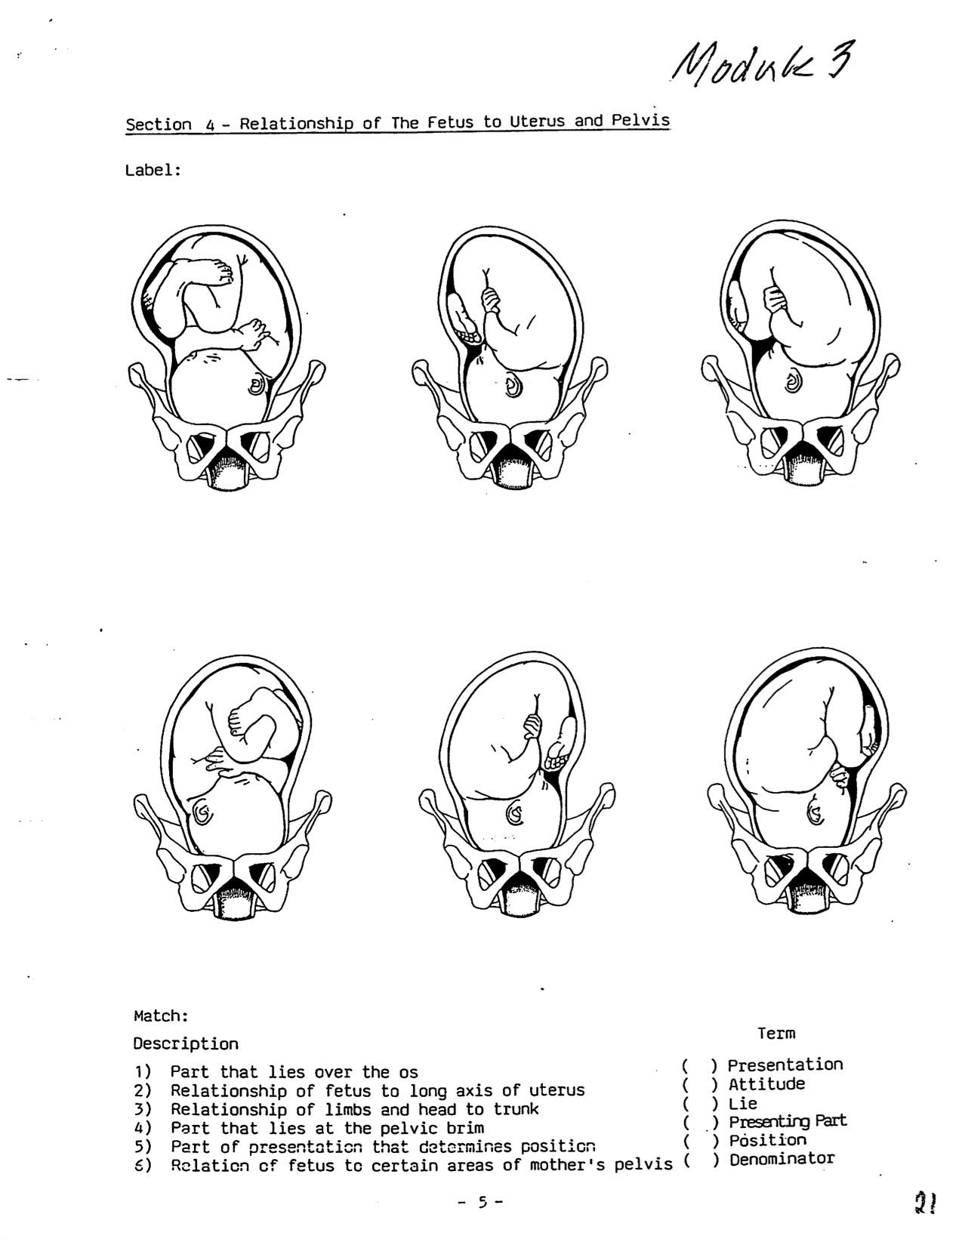

Diet Cover Sheet

For Diet A:

a) Your first impressions of this diet; hat sort of issues would you flag?

b) Nutritional deficiencies: be specific and exact regarding amounts of calories, protein, key minerals, all vitamins, fats, and liquids, calculated as total amounts of each per day

c) Counseling approach and suggested modifications taking into consideration odd eating patterns (restricted amounts that could indicate eating disorder), severly limited choices (could indicate lack of resources), unknown supplements (the midwife’s responsibility), and cultural preferences (how these may conflict in a partnership)

For Diets B, C, and D:

a) Your first impressions of this diet; what sort of issues would you flag?

b) Suspected nutritional deficiencies (you do not need to calculate, but may do so if you wish)

c) Counseling approach and suggested modifications taking into consideration odd eating patterns (restricted amounts that could indicate eating disorder), severly limited choices (could indicate lack of resources), unknown supplements (the midwife’s
responsibility), and cultural preferences (how these may conflict in a partnership)

Module Three: Prenatal Care, Part 2
3-Day Diets

Diet A
Monday
9 AM banana
1 PM mango
3 PM salad, spinach, red leaf lettuce, onion, parsley, raw mushroom, tomatoes, sprouts, zucchini, beets,
tofu burger slice bread with almond butter
5 PM grapes
8 PM spaghetti squash with margarine and honey

Tuesday
9 AM grapes apple cider
11 AM avocado, sprouts, I block tofu, I slice bread with soy margarine, soy braggs, tomato
12 PM I cookie
1 PM pear
3 PM tomato cucumber, salad w/parsley, onion, oil and vinegar, avocado, sprouts, tomato, onion on whole grain bread (2 slices)
vegetable juice, carrot, parsley, celery, spinach
5:30 PM I baked potato with margarine and honey
9 PM cup peppermint tea
10 PM bunch grapes
2:30 AM 2 figs, I bite dried pear

Wednesday
7 AM peach
8 AM 1/2 banana
9 AM 1/2 slice tofu. Tomato, sprouts, I small avocado w/braggs, 1/2 slice bread with almond butter,
11 AM 2 sour cherry candies
1 PM 5 dolmas (rice wrapped in grape leaves)
2 PM 1 baklava
peach juice I Calistoga water
3 PM 3 gulps orange juice
3:30 1 grapefruit
6 PM I avocado, slice bread with almond butter
7 PM I piece trident gum
1 AM 1 plum, bunch grapes

Diet B (same meal once a day for three days)
Black-eyed peas
White rice
Bacon ends
Fried cabbage

Diet C
Sunday
I carrot
3 glasses milk
peanut butter and jelly on whole wheat
deviled egg
3 slices veggie pizza
3 glasses apple juice
2 celery sticks
bowl black-eyed peas
I slice poppy seed cake
(2 green golds, 2 tienchi boosts, 1 wildfire, 3 garlics, 6 spirulina tablets)

Monday
Granola with milk
Carrot
2 glasses water
scrambled egg
slice whole wheat toast
hash browns
strawberry yogurt (I cup)
avocado sandwich with cheese, sprouts. Lettuce, tomato,
tortila chips and guacamole
glass milk
slice veggie pizza
slice cantaloupe
(1 OB-1, 1san shi dan, 3 garlics, 4 spirulina)

Tuesday
Granola with milk
2 glasses OJ
glass apple juice
2 glasses milk
2 bananas
24 strawberries
2 bowls boysenberry sherbet
2 toasts with butter
salad with tomatoes, sprouts. Cucumbers, sunflower seeds, lettuce, sprouts, and cheese
green apple
(1 OB-1, I jolli tea, 2 green golds, 2 tienchi boosts, 1 wildfire, 3 garlics, 1 san shi dan)

Diet D (hint: Asian woman, Irish husband)
Day one
Soft rice, half bowl, vegetable soup, I egg, 1/2 cup milk, 1 plum, 1/2 cup milk, beans, watermelon, fish, 1 cup plum juice

Day two
1/2 cup plum juice, vegetable soup (canned), 1 egg, 1/2 cup plum juice, 1/2 cup cranberry juice, 1/2 cup milk, beans, 1/2 cup vegetable juice, soft rice, 2 dried plums, a little fish, 1/2 cup plum juice, 1/2 cup lemon juice

Day three
1/2 cup plum juice, soft rice, 3 dried plums, 1 slice French bread, 1/2 cup milk, turkey, a little potato, 1 cup cranberry juice, lot of strawberry, 1 cup cranberry juice, 1/2 cup plum juice, 1/2 cup water

Module Three: Prenatal Care, Part 2
Post-Test

Please respond to these items as concisely as possible:
- Briefly describe the key phases of fetal development
- Give rationale, appropriate techniques, and response to abnormal findings for:
  - Fundal height assessment
  - Leopold’s maneuvers
  - Estimated fetal weight
  - Estimated amniotic fluid volume
  - Evaluation for multiple gestation
3) Give techniques for auscultating fetal heart tones as regards:
- How to locate
- Normal range
- Normal variability
- Abnormal findings and appropriate response
4) Briefly describe the difference between physiological and pathological edema in pregnancy
5) As stated in Heart & Hands, cite minimum daily nutritional and fluid requirements in pregnancy
6) For each trimester, cite appropriate frequency of prenatal visits, and identify the most crucial aspects of caregiving
7) Describe the purpose and features of home visit(s) in prenatal caregiving

Module Three: Prenatal Care, Part 2
Module Evaluation Sheet

- What did you like about this module?

- Were there any surprises for you in this module?

- Was there anything in his module that was particularly challenging for you?

- Do you feel you met this module’s stated learning objectives?

- Did the leaning activities enable you to meet the learning objectives?

- Were the suggested learning resources (books and materials) adequate to meet the learning objectives? Did you utilize additional resources?

- Any comments/suggestions for improving the module?

Heart & Hands Midwifery Intensives
BEGINNING/INTERMEDIATE MODULES

Module Four: Complications of Pregnancy

DESCRIPTION
This module covers physical complications that may occur during pregnancy. Students are introduced to principles of research, evidence-based practice, critical interpretation of professional literature, and the interpretation of vital statistics and research findings. Each student selects a topic from question 1) below, on which to complete a research project.

LEARNING OBJECTIVES
To identify and appropriately respond to complications of pregnancy:
1) Cite the symptomology, methods of diagnosis, significance and treatment of the following complications of pregnancy:
      - Nutritional anemias
      - Problems with weight gain
      - Miscarriage/abortion: threatened, spontaneous, incomplete, missed and habitual abortion
      - Ectopic pregnancy
      - Hydatidiform mole
      - Placenta previa
      - Placental abruption
      - Gestational diabetes
      - Gestational hypertension
      - Preeclampsia and eclampsia
      - Polyhydramnios
      - Oligohydramnios
      - Multiple pregnancy
      - Breech presentation and transverse lie
      - Prematurity
      - Intrauterine growth restriction
      - Small for gesttional age
      - Large for gestational age
      - Postdatism

LEARNING ACTIVITIES
- Read Heart & Hands, Chapter 3
- Create a chart, Physical Complications of Pregnancy (as covered in H&H Chapter 3), with two columns: How to Recognize (signs), and How to Respond (steps you, as midwife, will take). Keep your chart limited to just this information; make it a simple, trouble-shooting guide. NOTE: be sure to break out types of anemia, miscarriage, and bleeding in late pregnancy, and differentiate SGA from IUGR.
- Read “Using the Medical Literature” found at the end of this module, and watch this video on writing a research paper: https://www.youtube.com/watch?v=rqRv0OjPH4g&feature=youtu.be
- Use the above tools to write a research paper. This is a three step process:
  - Choose a topic from the learning objectives list that you wish to research, and email me your choice of topic, including a statement on why this topic appeals to you and what you hope or expect to find.
  - Write a 4 to 5 page draft of your paper, utilizing at least four references, with at least two current within the last five years. Do not cite articles, but cite the supporting studies, investigating them for legitimacy according to the guidelines presented in “Using the Medical Literature.” Be sure to use citations in MLA or footnote format.
c) I will return your draft with comments and questions to assist you in generating your final paper, which must be submitted before going on to module five. Be sure to add a conclusion to your paper, with an analysis of your research and comments regarding your original hopes or expectations in choosing this topic.

SUBMIT
  - Research paper: parts a and b in Learning Activity 5, above. After this has been reviewed and returned to you, submit your final version, along with the following:

  - Chart, Physical Complications of Pregnancy
  - Completed module post-test
  - Module Evaluation Sheet

COMPLETION REQUIREMENTS
In order to successfully complete this module, you must complete all learning activities and submit all items as listed above. All work must be your own, and in your own words! Your work will be reviewed item by item and scored with the rubric found in the INSTRUCTIONS; you must achieve 7.5 out of 10 to pass. You will have two opportunities to correct any errors/omissions in your work, at which point a final score will be assigned.

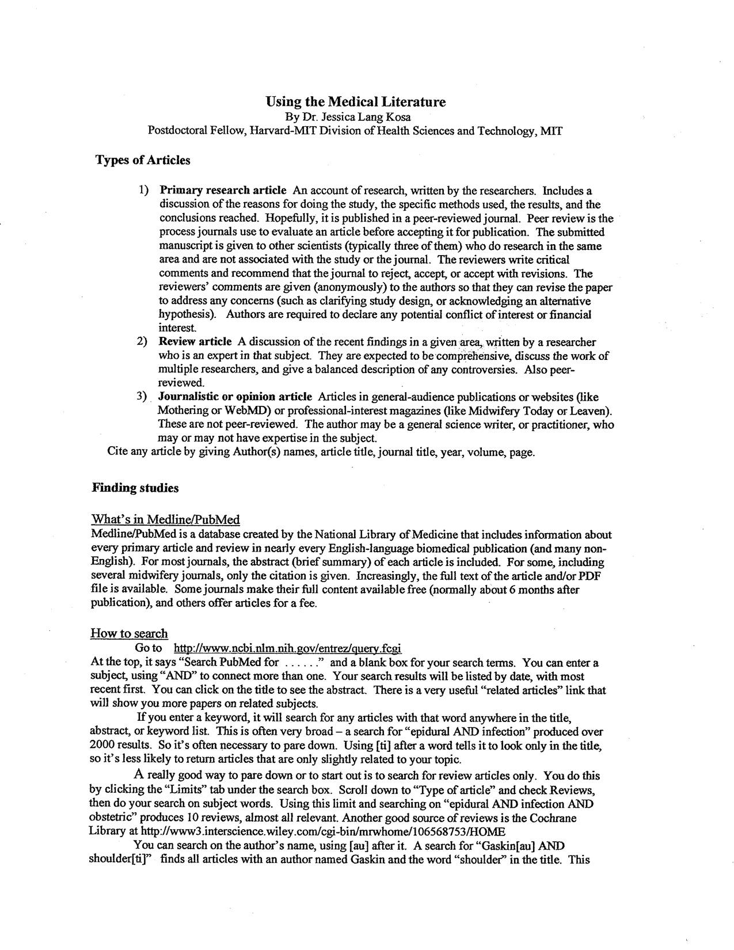
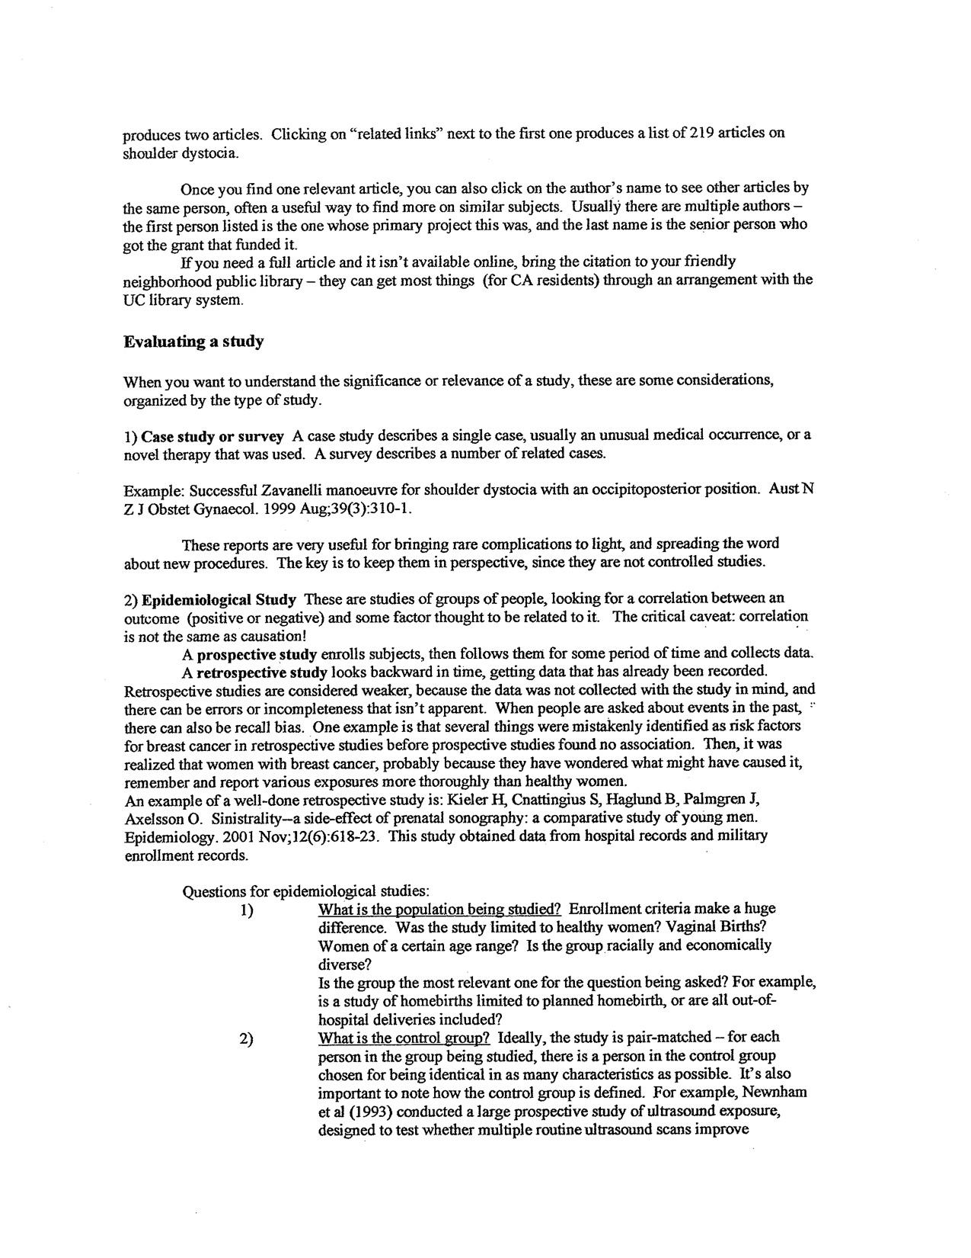
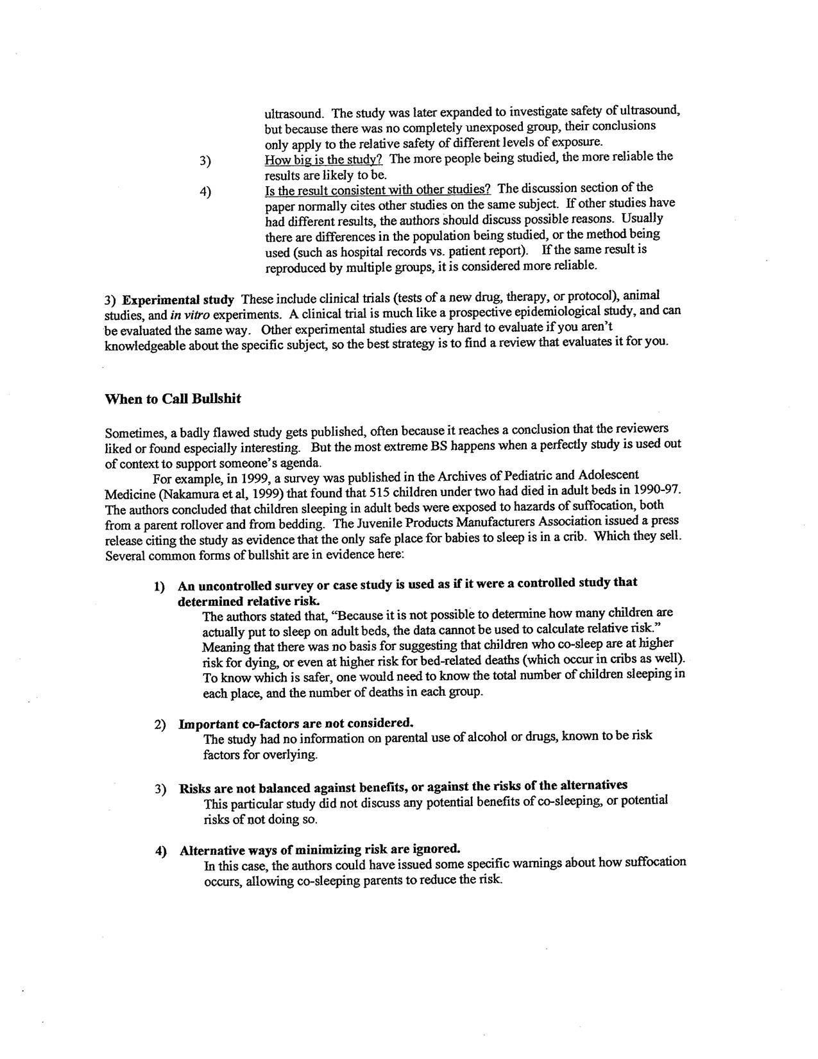

Module Four: Complications of Pregnancy
Post-Test

Please answer the following questions:
1. If a mother/gestational parent has iron deficiency anemia, their lab slip would probably show the M _____to be normal, but M_____ values will be low.
2. If they have B-12 anemia, the M_____ will be high. This type of anemia is also known as ________________________________________.
3. Your client calls at 19 weeks to report episodes of light brown bleeding over the last few days. Which two conditions do you most suspect, and how will you reach a diagnosis? (5 key points)
________________________________________________________________________________________________________________________________________________________
____________________________________________________________________________
________________________________________________________________________________________________________________________________________________________
4. What is the most noteworthy symptom of ectopic pregnancy prior to rupture?
_______________________________________.
5. True or False: trichomonias infection can be harbored in the male prostate _______.
6. True or False: herpes virus can be cured using natural remedies ________.
7. When is toxoplasmosis exposure is most dangerous to the fetus? ______________________________________________________________________.
8. Define cytomegalovirus, and risks to the fetus if exposed ____________________________________________________________________________
____________________________________________________________________________
9. What are common consequences to the fetus of rubella exposure in the first trimester? ____________________________________________________________________________
________________________________________________________________________________________________________________________________________________________
10. Any mother/gestational parent presenting symptoms of a UTI should also be screened for _________________________ by manually checking for____________________
11. Cite pregnancy/birth related risks for a) mother/gestational parent, and b) baby, of each of the following sexually transmitted infections
A. Herpes ____________________________________________________________________________
____________________________________________________________________________
B. Chlamydia ____________________________________________________________________________
____________________________________________________________________________
C. Strep-B (GBS)
____________________________________________________________________________
____________________________________________________________________________
D. HIV/AIDS ____________________________________________________________________________
____________________________________________________________________________
E. Hepatitis B ____________________________________________________________________________
____________________________________________________________________________
F. Hepatitis C
________________________________________________________________________________________________________________________________________________________________________________________________________________________________
11. What does IUGR stand for? _________________________________________________.
12. List three causes of IUGR _________________________, _______________________, __________________________
13. What are the clinical signs that distinguish IUGR from a SGA baby? ____________________________________________________________________________
____________________________________________________________________________
14. You discover that your client has low-grade polyhydramnios. What steps will you take upon making this diagnosis, and what possible risks might there be if your client gives birth at home? (6 key points)
____________________________________________________________________________
____________________________________________________________________________
____________________________________________________________________________
____________________________________________________________________________
15. Your client, now at 28 weeks, has shown a steady rise in blood pressure over the last month (no previous history of hypertension). Describe, in detail, your care plan at this point. (6 key points)
____________________________________________________________________________
____________________________________________________________________________
____________________________________________________________________________
____________________________________________________________________________
________________________________________________________________________________________________________________________________________________________
16. List the two earliest signs of pre-eclampsia, and how you would respond if your client manifested them. (5 key points)
____________________________________________________________________________
____________________________________________________________________________
________________________________________________________________________________________________________________________________________________________
17. If a mother/gestational parent is LGA, what might be five possible explanations?
_____________________________________ _____________________________________ __________________________________
_____________________________________ _____________________________________
18. What is the standard treatment for low-grade gestational diabetes? (4 key points)
________________________________________________________________________________________________________________________________________________________________________________________________________________________________________________________________________________________________________________
19. Your client arrives for a prenatal visit at 32 weeks, complaining of painless vaginal bleeding in the AM. What would you suspect, and what would be your response? (4 key points)
________________________________________________________________________________________________________________________________________________________________________________________________________________________________
________________________________________________________________________________________________________________________________________________________________________________________________________________________________
____________________________________________________________________________
20. What is a concealed abruption? What are classic signals? What are the dangers to mother/gestational parent and baby? (5 points)
________________________________________________________________________________________________________________________________________________________________________________________________________________________________________________________________________________________________________________________________________________________________________________________________________________________________________________________________
21. Give three risks associated with twin deliveries _____________________________ ,
_____________________________________, ______________________________________.
22. List three critical needs of the mother/gestational parent pregnant with twins ________________,
_____________________________________, ______________________________________.
23. What is the greatest immediate danger for the baby born prematurely? ___________________________________________
What signals of this danger/problem would the baby show at delivery? (4 points)
_____________________________________ _____________________________________
_____________________________________ _____________________________________
24. List the five post-dates evaluations for fetal dysmaturity and how the midwife can monitor EACH without utilizing ultrasound. (10 points)
_____________________________________ _____________________________________
_____________________________________ _____________________________________
_____________________________________ _____________________________________ _____________________________________ _____________________________________ _____________________________________ ____________________________________

____________________________________________________________________________

Module Four: Complications of Pregnancy
Module Evaluation Sheet

- What did you like about this module?

- Were there any surprises for you in this module?

- Was there anything in his module that was particularly challenging for you?

- Do you feel you met this module’s stated learning objectives?

- Did the leaning activities enable you to meet the learning objectives?

- Were the suggested learning resources (books and materials) adequate to meet the learning objectives? Did you utilize additional resources?

- Any comments/suggestions for improving the module?

Heart & Hands Midwifery Intensives
BEGINNING/INTERMEDIATE MODULES

Module Five: Labor Facilitation and Assessment

DESCRIPTION
This module covers the anatomy and physiology of normal labor, the birthing person’s emotional response, and essential physical assessments of mother and baby at all stages of labor, including fetal heart tone pattern assessment and appropriate response, and indications for internal exam.

LEARNING OBJECTIVES
To understand essentials of facilitating and assessing normal labor:
- Know the stages of labor, and physical/emotional symptoms of each
- Know the cardinal movements of the fetus during labor
- Define maternal needs for nutrition, rest, hydration, and activity in labor
- Discuss the significance of, and appropriate response to, vomiting in labor
- Know how to perform routine assessments of mother/gestational parent and fetus at each stage of labor, including deviations from normal and appropriate response
- Cite common techniques for facilitating progress in labor, including comfort measures
- Understand principles and practice of universal precautions
- Describe appropriate techniques for internal exam during labor
- Know how to determine fetal position, attitude, station, and cervical effacement, dilation, edema and proximity to the fetal skull by internal exam

LEARNING ACTIVITIES
- Read Heart & Hands, Chapter 4
- Read Orgasmic Birth, Chapters 1, 4 and 5
- Write a summary of normal labor, describing physiology and common emotional responses and needs of the mother/birthing person stage-by-stage (do not include midwife’s duties)
- Watch video on Cardinal Movements: https://youtu.be/odHEQNGph2Y
- Do worksheet, Cardinal Movements of the Fetus in Labor
- Watch videos on Fetal Heart Tones:
  - https://www.youtube.com/watch?v=MO1alMV65Oc
  - https://www.youtube.com/watch?v=lbFomCbMgnk
- Do worksheet, Fetal Heart Tones
- Journal work: If feasible, contact your biological mother for new/additional information regarding your birth

HANDS-ON LEARNING ACTIVITIES
- On a foam rubber ball (such as the ”Nerf Ball” child’s toy), draw, and etch out with razor blade: sagittal suture, and anterior and posterior fontanelles. Practice feeling ball with eyes closed, arranging it in positions likely to be found during internal exam (a loose sock may be stretched over the ball to simulate a dilated cervix, and to create asynclitic fetal positions.)

SUBMIT
- Worksheet, Cardinal Movements of the Fetus in Labor
- Summary of normal labor (detailed physiology, emotional responses of mother/gestational parent and common support measures)
- Outline--principles and practice of universal precautions
- Worksheet, Fetal Heart Tones (Note: Part B, appropriate response/ treatment, should be what you, as an out of hospital midwife, would do)
- Any questions or concerns arising from optional learning activity
- Module Evaluation Sheet

COMPLETION REQUIREMENTS
In order to successfully complete this module, you must complete all learning activities and submit all items as listed above. All work must be your own, and in your own words! Your work will be reviewed item by item and scored with the rubric found in the INSTRUCTIONS; you must achieve 7.5 out of 10 to pass. You will have two opportunities to correct any errors/omissions in your work, at which point a final score will be assigned.

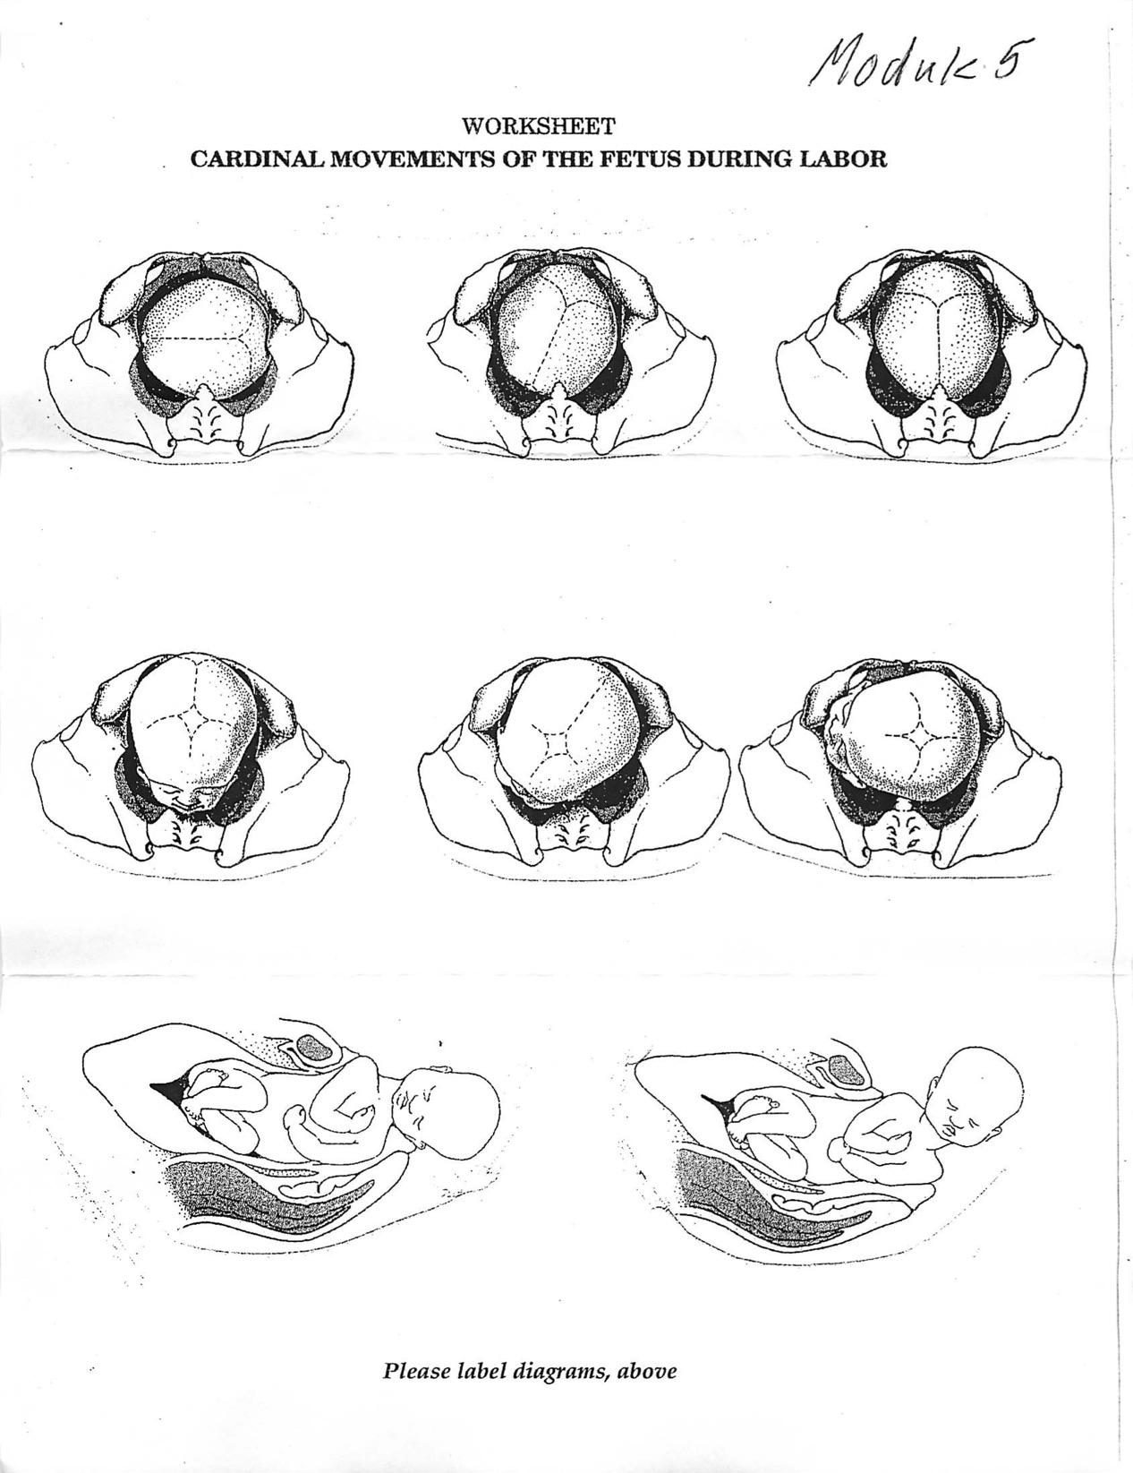
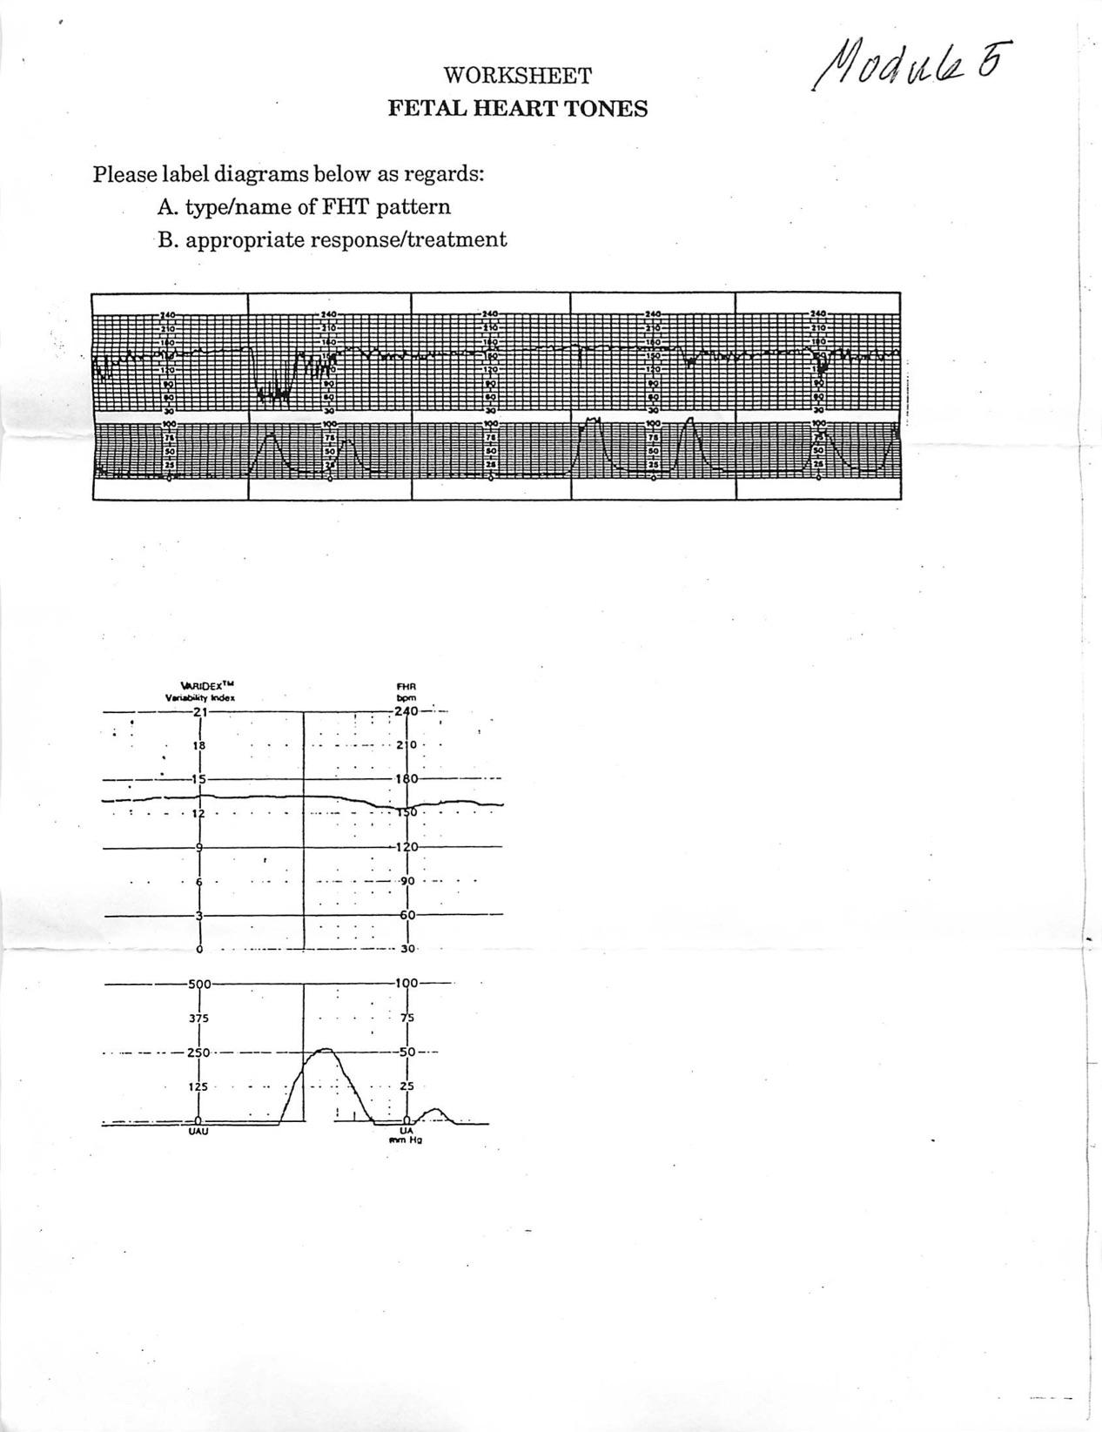
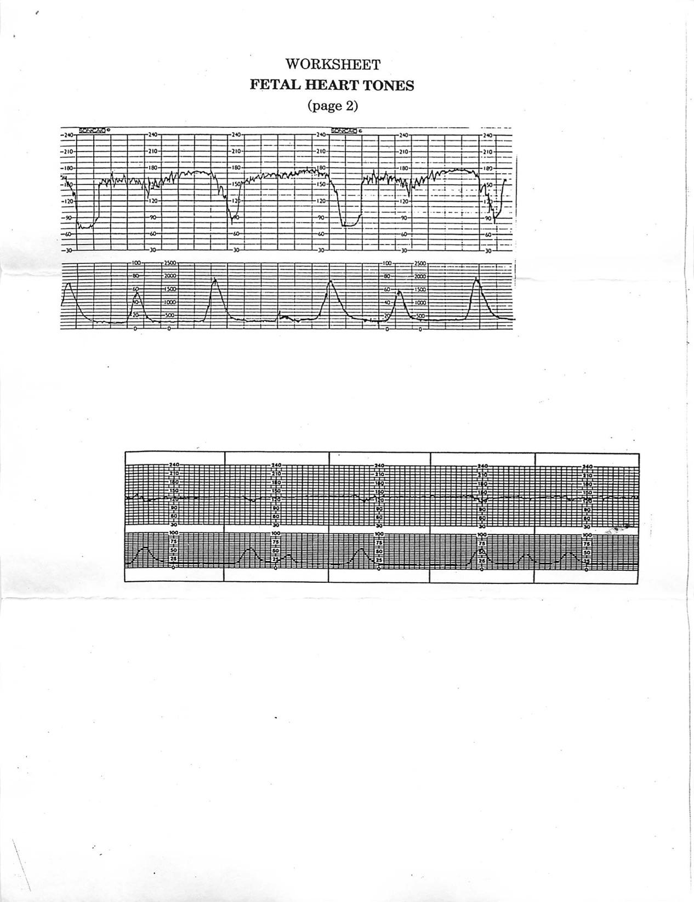

Module Five: Labor Facilitation and Assessment
Module Evaluation Sheet

- What did you like about this module?

- Were there any surprises for you in this module?

- Was there anything in his module that was particularly challenging for you?

- Do you feel you met this module’s stated learning objectives?

- Did the leaning activities enable you to meet the learning objectives?

- Were the suggested learning resources (books and materials) adequate to meet the learning objectives? Did you utilize additional resources?

- Any comments/suggestions for improving the module?

Heart & Hands Midwifery Intensives
BEGINNING/INTERMEDIATE MODULES

Module Six: Normal Delivery and
Immediate Care of the Newborn

DESCRIPTION
This module covers meconium staining, appropriate hand maneuvers for a vertex birth, and principles of prevention of pelvic floor damage and perineal tears. Key factors in stabilizing the newborn and the gestational parent in the immediate postpartum are addressed, along with how to provide a safe environment for the gestational parent and infant that promotes attachment (bonding). Ways to support the newborn’s microbiome are presented, and Newborn Exam is detailed.
Note: this is a longer module, than the others, but module 8 will be lighter.

LEARNING OBJECTIVES
To understand how to facilitate advanced labor, delivery, and care of the newborn:
- Explain the significance of meconium staining of amniotic fluid during labor, with appropriate response
- Describe techniques to help prevent perineal tears
- Identify hand maneuvers that may be utilized at delivery
- Define the microbiome as applied to the newborn, with guidelines for maintaining microbiome health
- Cite key factors in stabilizing the newborn
- Cite key factors in maternal stabilization in the immediate postpartum period
- Describe routine newborn examination, explaining the significance of, and appropriate response to, any abnormal findings
- Define techniques for APGAR scoring, including significance of, and appropriate response to, abnormal findings
- Describe crucial maternal and newborn assessments in the immediate postpartum period
- Know principles of maternal-infant bonding, and how to facilitate
- Know ways to help mother/gestational parent initiate breastfeeding
- Cite postpartum instructions for parents

LEARNING ACTIVITIES
- Re-read Heart & Hands, Chapter 4, focusing on care during second stage and immediate postpartum, and Chapter 5, section on Infant Resuscitation
- Write a brief summary of principles for preventing vaginal/perineal tears, and hand maneuvers at delivery
- Listen to this podcast or watch movie on the microbiome: https://birthful.com/?s=microbiome
- Do module post-test
- Based on material in Chapter 4, Heart & Hands, prepare a chart, as follows:
  - Title-- Midwife’s Duties and Responsibilities During Labor
  - Organization--divide labor into the following stages: early labor; active labor/transition; second stage; delivery; third stage, and immediate postpartum (until you leave)
  - Format—divide page into two columns.
On the Left, list duties/assessments (no description needed) with recommended frequency
On the Right, cite possible borderline findings—red flags of each assessment, with midwife’s management/response (use the “if…then” format)
Do not include anything else—this is a simple trouble-shooting guide using Heart & Hands, chapter 4.
Do not include specifics of Newborn Exam, as it is covered elsewhere in your coursework.
d) Example:
____________________________________________________________________________
ACTIVE LABOR/TRANSITION
Duties/Assessments . Borderlines/management
1) Take fetal heart tones every 1/2 hour 1) A. If variable decelerations, change Mom’s
position
B. If late decels, flat baseline or bradycardia,
give oxygen and transport
C. If early decels, rule out CPD/malpresentation
D. If tachycardia, rule out maternal
exhaustion/infection, chorioamnionitis

2) Coordinate birth team 2) If anyone sleepy or anxious, have them
leave the room for rest/rejuvenation, and spell
mother/gestational parent’s partner if need be
____________________________________________________________________________
SUBMIT
1) Summary on preventing tears/hand maneuvers at delivery
2) Completed module post-test
3) Chart, Midwife’s Duties and Responsibilities During Labor
4) Module Evaluation Sheet

COMPLETION REQUIREMENTS
In order to successfully complete this module, you must complete all learning activities and submit all items as listed above. All work must be your own, and in your own words! Your work will be reviewed item by item and scored with the rubric found in the INSTRUCTIONS; you must achieve 7.5 out of 10 to pass. You will have two opportunities to correct any errors/omissions in your work, at which point a final score will be assigned.

Module Six: Normal Delivery and Immediate Care of the Newborn
Post-Test

Please respond to these items as concisely as possible:
1. Give two reasons why a mother/gestational parent should urinate immediately before entering second stage
2. Describe the difference between old or fresh amniotic fluid staining as regards:
- appearance
- significance
- appropriate response (use current Neonatal Resuscitation guidelines)
3. Define the microbiome as applied to the newborn, with guidelines for maintaining microbiome health
4. Cite the two key factors for stabilizing the newborn
5. Describe the appropriate response to a newborn with an at-birth APGAR score of 9, of 6, of 2, of 0.
6. Cite three key factors for maternal stabilization immediately postpartum
7. Describe how to help mother/gestational parent initiate breastfeeding
8. Describe how to facilitate maternal-infant bonding in immediate postpartum
9. Using the Newborn Exam form (Heart & Hands, Appendix H ), cite normal/abnormal findings for each category and indicate which abnormal findings require immediate transport/care of a physician (if you need more room, you may use a separte sheet of paper to write out your responses)

Module Six: Normal Delivery and Immediate Care of the Newborn
Module Evaluation Sheet

- What did you like about this module?

- Were there any surprises for you in this module?

- Was there anything in his module that was particularly challenging for you?

- Do you feel you met this module’s stated learning objectives?

- Did the leaning activities enable you to meet the learning objectives?

- Were the suggested learning resources (books and materials) adequate to meet the learning objectives? Did you utilize additional resources?

- Any comments/suggestions for improving the module?

Heart & Hands Midwifery Intensives
BEGINNING/INTERMEDIATE MODULES

Module Seven: Complications of Labor, Part 1

DESCRIPTION
This module covers approximately half of the complications that may occur during labor, as regards etiology, symptomology, diagnosis, significance, and treatment. Technique for intramuscular injection of oxytocics is introduced, with indications and contraindications. Students prepare a research project on a complication of their choice from lists in module seven or module eight, employing principles of research, evidence-based practice, critical interpretation of professional literature, and the interpretation of vital statistics and research findings.

LEARNING OBJECTIVES
To be able to identify and appropriately respond to common complications of labor and delivery:
- Explain the etiology, symptomology, methods of diagnosis, significance and treatment of the following complications of labor and delivery:
  - Prolonged labor
  - Maternal exhaustion
  - Relative cephalopelvic disproportion, including posterior arrest, asynclitism, and deep tranverse arrest
  - True cephalopelvic disproportion
  - Retained placenta
  - Partial separation of the placenta in 3rd stage
  - Third stage hemorrhage
  - Fourth stage hemorrhage
- Cite indications/contraindications for intramuscular injections of oxytocics
- Describe appropriate technique for intramuscular injections

LEARNING ACTIVITIES
- Read Heart & Hands, Chapter 5
- Reread “Using the Medical Literature” found at the end of module four, and utilize it to write a research paper. Choose a topic from the learning objectives list for this module and the list in Module Eight that you wish to research, and write a 4 to 5 page paper, utilizing at least four references, with at least two current within the last five years. Do not cite articles, but cite the supporting studies, investigating them for legitimacy according to the guidelines presented in “Using the Medical Literature.” Be sure to use citations in MLA or footnote format.

HANDS-ON LEARNING ACTIVITIES
- Estimating blood loss:
  - Measure 2 cups water, add 2 tsp. of red food color, and pour, 1/2 cup at a time, on a large disposable underpad. Note size of the “blood” puddle at each interval, and lift pad at each interval to assess weight.
  - Have a friend pour an undisclosed amount of “blood” onto a clean underpad, and try to estimate blood loss (repeat several times).

SUBMIT
1) Research paper
2) Completed module post-test
3) Any questions arising from optional learning activity
4) Module Evaluation Sheet

COMPLETION REQUIREMENTS
In order to successfully complete this module, you must complete all learning activities and submit all items as listed above. All work must be your own, and in your own words! Your work will be reviewed item by item and scored with the rubric found in the INSTRUCTIONS; you must achieve 7.5 out of 10 to pass. You will have two opportunities to correct any errors/omissions in your work, at which point a final score will be assigned.

Module Seven: Complications of Labor, Part 1
Post-Test

Please answer the following questions:
1. What might you do to support a mother/gestational parent plateauing at:
4 cm
________________________________________________________________________________________________________________________________________________________________________________________________________________________________________________________________________________________________________________

8-9 cm ________________________________________________________________________________________________________________________________________________________________________________________________________________________________
____________________________________________________________________________

Crowning
______________________________________________________________________________________________________________________________________________________________________________________________________________________________
____________________________________________________________________________
2. Arrested progress at 6 cm is typically physically based. Explain why ________________________________________________________________________________________________________________________________________________________________________________________________________________________________
____________________________________________________________________________
3. CPD stands for _____________________________________________________________
4. You would suspect CPD in the last weeks of pregnancy if you noticed ________________________________________________________________________________________________________________
5. During labor, three signs (not types) of CPD include: ___________________________________
___________________________________ _______________________________________
6. What suggestions/procedures might you use for a mother /gestational parent with a persistent anterior lip? _______________________________________________________________________________________________________________________________________________________________________________________________________________________________________________________________________________________________________________

7. Give a common indication and appropriate timing and procedure for performing AROM during labor ________________________________________________________________________________________________________________________________________________________________________________________________________________________________________________________________________________________________________________
____________________________________________________________________________8. Describe what happens physically to cause posterior arrest ____________________________________________________________________________
____________________________________________________________________________________________________________________________________________________________________________________________________________________________________
9. Asynclitism may result from (list 2) ________________________________________________________________________________________________________________________________________________________
10. Anterior / Posterior (highlight one) asynclitism is identified when the sagittal suture line runs asymmetrically across the cervical opening, high and toward the vaginal vault.
11. It is best to attempt any manual repositioning/rotation of the fetal head with the membranes ______________________________
12. Clinical signs of maternal exhaustion include (list 3) _____________________________________
_____________________________________ _____________________________________
13. The baby of a mother/gestational parent suffering from exhaustion is predisposed to: ______________________________
14. Sometimes blood loss is normal in labor. Describe this, in terms of consistency and amount ________________________________________________________________________________________________________________________________________________________
15. Describe the steps you would take in the event of partial separation of the placenta (third stage). Include guidelines for torrential and for slow, periodic blood loss. (5 points) ____________________________________________________________________________________________________________________________________________________________________________________________________________________________________________________________________________________________________________________________________________________________________________________________________________________________________________________________________________________________________________________________________________________________________________________________________________________________________________________________________________________________________________
16. Normal blood loss in the immediate postpartum should be no more than ________________________
17. Your client has lost 600 ccs blood after delivering her/their placenta and still continues to trickle. Before giving oxytocics, you must rule out (list 3) ____________________________________________________________________________________________________________________________________________________________________________________________________________________________________
18. A placenta which does not deliver spontaneously is termed ______________________ and may be due to a pathological condition known as _____________________________
19. Name an optimal site for an intramuscular injection ____________________________________________________________________________
20. While giving an intramuscular injection, one must always remember to _____________________________________________to be certain ___________________________________________________ before actually injecting the medication.
21. Name a significant contraindication for Methergine injection as per maternal history ___________________________________________________________________________
22. In the event of postpartum hemorrhage, 10 cc. ampules of Pitocin can be injected intramuscularly every ________________ minutes.
23. Contaminated needles are considered __________________________________________ and must be disposed of accordingly.

Module Seven: Complications of Labor, Part 1
Module Evaluation Sheet

- What did you like about this module?

- Were there any surprises for you in this module?

- Was there anything in his module that was particularly challenging for you?

- Do you feel you met this module’s stated learning objectives?

- Did the leaning activities enable you to meet the learning objectives?

- Were the suggested learning resources (books and materials) adequate to meet the learning objectives? Did you utilize additional resources?

- Any comments/suggestions for improving the module?

Heart & Hands Midwifery Intensives
BEGINNING/INTERMEDIATE MODULES

Module Eight: Complications of Labor and Delivery,
Part 2

DESCRIPTION
This module covers additional complications that may occur during labor, as regards etiology, symptomology, diagnosis, significance, and treatment. Ways to effectively facilitate transport and transfer of care are addressed, and indications for neonatal testing are covered.

LEARNING OBJECTIVES
To understand how to identify and appropriately respond to common complications of labor, delivery, and the newborn:
- Explain the etiology, symptomology, methods of diagnosis, significance and treatment of the following complications of labor and delivery:
  - Fetal distress
  - Cord compression/prolapsed cord
  - Prolonged rupture of the membranes
  - Breech presentation
  - Shoulder dystocia
  - Fetal anomalies--cleft palate, spina bifida, polycystic kidneys, esophageal atresia, congenital heart defects, hydroencephaly, anencephaly, trisomies 18 and 21, imperforate anus, etc.
  - Fetal demise
- Identify ways to effectively transfer care and work cooperatively with back up
- Understand principles of client advocacy/informed choice
- Cite indications/contraindications for routine neonatal testing

LEARNING ACTIVITIES
- Review Heart & Hands, Chapter 5, on complications listed in Learning Objectives, above
- Read Heart & Hands, Chapter 6, “The Baby: Complications and Concerns” and Chapter 8, “Medical Records, Charting, Informed Choice…”
- Complete module post-test

SUBMIT
- Completed module post-test
- Module Evaluation Sheet

COMPLETION REQUIREMENTS
In order to successfully complete this module, you must complete all learning activities and submit all items as listed above. All work must be your own, and in your own words! Your work will be reviewed item by item and scored with the rubric found in the I INSTRUCTIONS; you must achieve 7.5 out of 10 to pass. You will have two opportunities to correct any errors/omissions in your work, at which point a final score will be assigned.

Module Eight: Complications of Labor and Delivery, Part 2
Post-Test

Please answer the following questions:
1. What is the primary danger involved in breech delivery? ____________________________
2. In assisting a breech birth, once the legs have delivered and there is no tension on the cord, you should rule out ___________________________________________________________________________
and make sure the baby’s head is in _______ position. Flexion of the head during delivery is maintained by ___________________________________________.
3. The delivery of twins or large babies is correlated to postpartum hemorrhage because ____________________________________________________________________________
4. What steps should you take in case of prolapsed cord? (4 points)
________________________________________ ________________________________________
________________________________________ ________________________________________
5. List the three classic signs of shoulder dystocia ________________________________________
________________________________________ ________________________________________
6. You are confronted with a shoulder dystocia with mother/gestational parent in forward leaning position in the birth tub. How will you respond? (3 key points)
________________________________________________________________________________________________________________________________________________________________________________________________________________________________________________________________________________________________________________
7. You are assisting a mother/gestational parent with negative GBS status who calls to report SROM. How will this affect your care, and what is your advice to your client? (6 points) ____________________________________________________________________________________________________________________________________________________________________________________________________________________________________________________________________________________________________________________________________________________________________________________________________________________________________________________________________________________________________________________________________________________
8.The risk of infection with PROM is increased most dramatically by ____________________________________________________________________________
9. If you cannot hear the FHT at home in very late second stage, what else might you use as an indicator of fetal wellbeing? ____________________________________________________________________________

10. Match the following fetal anomalies with definitions, below (definitions may be used twice):
_____A. Cleft palate
_____B. Spina bifida
_____C. Suspected polycystic kidneys
_____D. Suspected esophageal atresia
_____E. Suspected congenital heart defects
_____F. Hydroencephaly
_____G. Anencephaly
_____H. Suspected Down syndrome
_____I. Suspected imperforate anus
1. Correlates to low ear placement
2. Excess fluid
3. Leads to abdominal distention
4. Risk increases dramatically with advanced maternal age
5. Incompatible with life
6. Correlated to asymmetrical femoral pulses
7. Sinuses/exposed meninges
8. Complicates breastfeeding
11. The baby has just been born, and you discover it has spina bifida. Your response? (2 points) ____________________________________________________________________________________________________________________________________________________________________________________________________________________________________
12. Common signals in the immediate postpartum of congenital heart defects are (list 2) ________________________________________________________________________________________________________________________________________________________
13. You must transport a client in labor due to fetal distress, thus transferring care to a physician. Under these circumstances it is crucial to (3 points) ________________________________________________________________________________________________________________________________________________________________________________________________________________________________________________________________________________________________________________
14. Give suggestions for facilitating birth with fetal demise, or handling a stillbirth:
(6 points)
____________________________________________________________________________________________________________________________________________________________________________________________________________________________________________________________________________________________________________________________________________________________________________________________________________________________________________________________________________________________________________________________________________________
15. Cite indications for the following neonatal tests:
A. Dextrostix ________________________________________________________________________________________________________________________________________________________________________________________________________________________________________________________________________________________________________________
B. Blood/gastric aspirate cultures ________________________________________________________________________________________________________________________________________________________________________________________________________________________________________________________________________________________________________________
C. Bilirubin count ________________________________________________________________________________________________________________________________________________________________________________________________________________________________________________________________________________________________________________
D. Calcium levels ________________________________________________________________________________________________________________________________________________________________________________________________________________________________________________________________________________________________________________
E. Lung X- ray ________________________________________________________________________________________________________________________________________________________________________________________________________________________________________________________________________________________________________________
F. Blood type
________________________________________________________________________________________________________________________________________________________
G. Rh factor
________________________________________________________________________________________________________________________________________________________
16. Drawing on chapter 8, Heart & Hands, describe appropriate ways to:
A. Inform a client regarding a suggested test/procedure ________________________________________________________________________________________________________________________________________________________________________________________________________________________________________________________________________________________________________________________________________________________________________________________________________________________________________________________________________________________________________________________________________________________________________________________________________________________________
B. Advocate/support client choice regarding a suggested test/procedure
____________________________________________________________________________________________________________________________________________________________________________________________________________________________________________________________________________________________________________________________________________________________________________________________

Module Eight: Complications of Labor and Delivery, Part 2
Module Evaluation Sheet

- What did you like about this module?

- Were there any surprises for you in this module?

- Was there anything in his module that was particularly challenging for you?

- Do you feel you met this module’s stated learning objectives?

- Did the leaning activities enable you to meet the learning objectives?

- Were the suggested learning resources (books and materials) adequate to meet the learning objectives? Did you utilize additional resources?

- Any comments/suggestions for improving the module?

Heart & Hands Midwifery Intensives
BEGINNING/INTERMEDIATE MODULES

Module Nine: Postpartum Care and Suturing

DESCRIPTION
This module covers care for the gestational parent and newborn postpartum, including the normal physiology of postpartum recovery, common complaints and complications. Diagnosis and treatment of vaginal/perineal tears is covered, as well as the physiology of milk production and ways to promote successful breastfeeding. Differentiating postpartum blues from postpartum depression is also addressed, with appropriate response.

Note: this is a longer module, than others, but module 10 will be lighter.

LEARNING OBJECTIVES
To know how to care for mothers/gestational parents and newborns postpartum:
- Give diagnosis and treatment for first, second, third and fourth degree vaginal lacerations
- Cite methodology, indications, and contraindications for vaginal/perineal infiltration with repair
- Describe how to repair a second-degree episiotomy/laceration
- Describe appropriate post-care of vaginal/perineal repair (by both mother/gestational parent and midwife)
- Describe crucial assessments of mother/gestational parent and baby at day-one, day-three, day-seven, and the six-week postpartum visit, including abnormal findings and appropriate response
- Describe normal physiology of postpartum recovery
- Explain the physiology of human milk production, and mechanics of successful breastfeeding
- Give differential diagnosis and treatment of breast engorgement and mastitis
- Cite common maternal complaints in the postpartum period, with remedies
- Cite common problems/difficulties regarding the newborn, with remedies
- List criteria for differentiating postpartum blues from postpartum depression, with appropriate response
- Outline care at six-weeks check-up, including family planning

LEARNING ACTIVITIES
- Review Heart & Hands, Chapter 5 (suturing sections)
- Watch video on Perineal Repair (not my technique exactly, but close enough)
  - https://www.youtube.com/watch?v=i60lk2GDFlc
- Do worksheet, Vaginal/Perineal Repair
- Read Heart & Hands, Chapter 6
- Finish reading Orgasmic Birth
- Read Dr. Jack Newman’s Guide to Breastfeeding (Newman, Pitman)
- Using the format described in Module Six, prepare a chart titled, Midwife’s’ Duties and Responsibilities in Postpartum Care, organizing information according to day of assessment, i.e., day-one, day-three, day-seven, and six-week check-up
- Compile a list of support organizations for new parents in your community, including those offering help in the event of neonatal death or disability

HANDS-ON LEARNING ACTIVITIES
- Using a foam rubber cube or car wash sponge, and suturing equipment (an upholstery needle and thread may be used instead of suture material, with a borrowed needle holder or one inexpensively purchased through a birthing supply website), practice the repair of a second-degree laceration, with directions in Heart & Hands, Chapter 5, and guidance from the video on Perineal Repair.

SUBMIT
- Worksheet, Vaginal/Perineal Repair
- Chart, Midwife’s Duties and Responsibilities in Postpartum Care
- List of community resources for new parents
- Completed module post-test
- Response paper (2 or 3 pages) on Orgasmic Birth (entire book), addressing how it impacted you and your beliefs around labor and birth
- Photos of suturing sample (may be submitted by email or text to (707) 695-6520)
- Module Evaluation Sheet

COMPLETION REQUIREMENTS
In order to successfully complete this module, you must complete all learning activities and submit all items as listed above. All work must be your own, and in your own words! Your work will be reviewed item by item and scored with the rubric found in the INSTRUCTIONS; you must achieve 7.5 out of 10 to pass. You will have two opportunities to correct any errors/omissions in your work, at which point a final score will be assigned.

Worksheet
VAGINAL/PERINEAL REPAIR

1. Describe structures involved in, and appropriate response to first degree, second degree, third degree, and fourth degree tears of the labia, vagina and perineum

2. List indications and contraindications for vaginal/perineal infiltration

3. Give a basic description of the repair of a second-degree episiotomy/laceration (step-by-step, and how you transition from one to the next)

4. Describe appropriate follow-up care of repair by both mother/gestational parent and midwife

5. Describe causes and appropriate response to:
A. Hematoma: a) without repair, and b) with repair

B. Infection of vaginal/perineal repair

C. Break down or inadequate healing of vaginal/perineal repair

Module Nine: Postpartum Care and Suturing
Post-Test

Please respond to these items as concisely as possible:
- Describe the physiology of human milk production, and keys to successful breastfeeding
- Give differential diagnosis and treatment of breast engorgement and mastitis
- Give differential diagnosis and treatment of postpartum blues and postpartum depression
- Differentiate the: a) symptoms, b) time of occurrence, and c) treatment of physiologic and pathological jaundice
- Define thrombophlebitis, and its relationship to pulmonary embolism
- Give causes, symptoms and treatment of neonatal infection (up to day five)

Module Nine: Postpartum Care and Suturing
Module Evaluation Sheet

- What did you like about this module?

- Were there any surprises for you in this module?

- Was there anything in his module that was particularly challenging for you?

- Do you feel you met this module’s stated learning objectives?

- Did the leaning activities enable you to meet the learning objectives?

- Were the suggested learning resources (books and materials) adequate to meet the learning objectives? Did you utilize additional resources?

- Any comments/suggestions for improving the module?

Heart & Hands Midwifery Intensives
BEGINNING/INTERMEDIATE MODULES

Module Ten: Professional Opportunities and Summary

DESCRIPTION
This module covers preparedness for further midwifery study. Students prepare a resume suitable for application to clinical/apprenticeship training. They also complete a self-assessment worksheet identifying their learning strengths and weaknesses thus far in their studies, and assess their preparedness for and needs regarding further education/training.

LEARNING OBJECTIVES
To identify educational and professional opportunities for student midwives:
- Identify local and out-of-state clinical training opportunities
- Learn more about local midwifery practice, by means of interview
- Participate in a community midwifery meeting or conference
- Prepare a resume suitable for application to an apprenticeship position (
- Identify learning strengths and weaknesses thus far in studies
- Assess personal preparedness for further education/training

LEARNING ACTIVITIES
1) Research local and out-of-state clinical training opportunities. If you are apprenticing, explain how you found this placemen
2) Interview a midwife in your community, regarding the following:
  - Training (and her opinion regarding training)
  - Philosophy of practice
  - Package of care (what’s included)
  - Expectations of her client
  - Her expectations of students/apprentices
  - Favorite and least favorite things about midwifery practice
  - Concerns for midwifery’s future
3) Attend a midwifery meeting in your community. If not availavle, attend a state midwifery meeting, NACPM chapter meeting, or a midwifery conference
4) Read Heart & Hands, Chapter 7

SUBMIT
- Results of research regarding local and out-of-state clinical training opportunities, if required
- Interview with midwife, with brief analysis/commentary
- Reflections on community midwifery meeting or other option, as listed above
- Self-Assessment Worksheet
- Module Evaluation Sheet

COMPLETION REQUIREMENTS
In order to successfully complete this module, you must complete all learning activities and submit all items as listed above. All work must be your own, and in your own words! Your work will be reviewed item by item and scored with the rubric found in the INSTRUCTIONS; you must achieve 7.5 out of 10 to pass. You will have two opportunities to correct any errors/omissions in your work, at which point a final score will be assigned.

Worksheet
SELF-ASSESSMENT

Please evaluate your progress in the Heart & Hands Beginning/Intermediate Course Work, as regards the following:

1) Academic proficiency:

2) Self-awareness/personal growth:

3) Independent, critical thinking:

4) Technical knowledge/proficiency:

5) Ability to self-direct learning:

6) Greatest strengths as a student:

7) Areas for improvement:

8) Priorities regarding further education/training:

Module Ten: Professional Opportunities and Summary
Module Evaluation Sheet

- What did you like about this module?

- Were there any surprises for you in this module?

- Was there anything in his module that was particularly challenging for you?

- Do you feel you met this module’s stated learning objectives?

- Did the leaning activities enable you to meet the learning objectives?

- Were the suggested learning resources (books and materials) adequate to meet the learning objectives? Did you utilize additional resources?

- Any comments/suggestions for improving the module?

